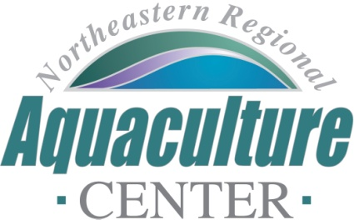
University of Maryland, 2113 Animal Science Building
College Park, Maryland 20742-2317
Telephone: 301-405-6085, FAX: 301-314-9412
e-mail: ssadams@umd.edu

NRAC FULL PROPOSAL REVIEW FORM

Project Code/Title: 23-07: Defining the development of larval immune systems in lumpfish and yellowtail.
Date Due: December 9, 2022.
- Science, Technology, and/or Extension Program Design (technical merit of all aspects of the project, 30%):

The overall goal of this project is to understand the immune status of the egg and larvae to help develop appropriate and effective hatchery management practices for lumpfish and yellowtail. The project addresses TRA-23-2 goal of “Research and demonstrate opportunities and methods that can lead to greater commercial profitability , viability and/or sustainability. Understanding the health requirements of these important aquaculture finfish species (lumpfish and yellowtail) is vital to ensure that culture conditions can be optimized.

The proposal is clearly written and well detailed, as well as being supported by informative illustrations that guide the reader. The experimental designs appear robust, although some information on sample sizes would have been beneficial to better understand the scale of the scope of work (although some of these details are provided in the budget narrative).

Excellent 28

- Industry Relevance and Probability of Success (30%):

The proposed work will advance the field of our understanding of the immune systems of these fish, thereby advancing the effectiveness of health management protocols that will be adoptable by industry. Given the robust nature of the proposal and the expertise of the project team, the probability of success appears to be very high.

Excellent 30

4. Integration with Extension (20%):

The investigators are well connected to the stakeholders and end users of the developed research and technology, having engaged both Kingfish Maine and Cooke Aquaculture. Two members of the project team (Fairchild and Bowden) are well equipped to lead the extension components of the project, and the outreach plan outlined in the proposal is comprehensive.

Excellent 20
4. Capacity (10%): Is (are) the principal investigator(s) and specified members of the research (extension) team qualified to conduct the research (program)? Is there industry representation as part of the team? Have the investigators clearly articulated they have adequate facilities and equipment to complete the project. Is the overall budget appropriate given the scope of the project? Is there a reasonable chance the project will be completed on-time?

The investigators are expertly positioned to conduct the proposed research as they are working in relevant fields and have strong track records in the necessary disciplines. The project team includes both Kingfish Maine and Cooke Aquaculture as industry representatives, both of whom express direct connections to the research. There are state-of-the-art facilities readily available to conduct the work and a diverse array of facilities within which to conduct the research (both in academic and industry settings). The budget is accurate, appropriate and well detailed.

Excellent 10

5. Accountability (10%): Does the investigator and her/his team have a successful track record of previous NRAC funding being adopted by the industry? Have they leveraged NRAC funding for additional resources to solve bigger problems that can be funded by NRAC alone? Is there evidence that the investigator(s) has (have) an established record indicating a high probability of success on the proposed work? Does the PI(s) have an established record of completing projects on-time meeting the objectives laid out in previous projects? Can this project integrate or be leveraged with funding from other work of the investigator(s)? Does the investigator(s) have a track record that suggests this project will be a good investment for NRAC resources?

Across the project team, there is extensive previous NRAC-funded research, as well as multiple cases of NRAC grants leading to successful awards of larger grants and adoption of previous NRAC results in the form of Cooke Aquaculture building a lumpfish production facility in Eastport, ME, the first of its kind in the US.

Excellent 10

6. Total score: 98

Rating Excellent

Final Recommendation: Must fund

